THE BROADSHEET Issue No.12
Autumn 2011

THE VOICE OF THE FRIENDS OF BROADWATER AND WORTHING CEMETERY___________

NEW STYLE BROADSHEET
FOR OUR THIRD ANNIVERSARY

I am delighted to announce that in the perpetual quest for improvement to enhance the product this 12th issue of THE BROADSHEET includes photographs for the first time. As an author/photographer your Editor would like to have included illustrations in our journal at a much earlier stage but the issues and obstacles have been a more ink-extravagant product for hard copy versions, an increase in the length of the document at the expense of other content, an over elaborate product for the likely circulation and readership numbers, and my limited technical IT competence.

However with the technical encouragement of Friend Sue Nea, who I publicly thank, it has been possible with this, our Third Anniversary issue, to incorporate a number of photographs. It will not be possible to produce a 'photograph album' every quarter but it is my intention to include up to a maximum of four reproductions per issue; above that the file becomes too large to transmit. With our regular News features, Nature Watch, Researcher's Corner, and Coming Events, as well as ad hoc items THE BROADSHEET has now attained a reasonable standard in its gradual development. I feel we have now reached a stage where consolidation can be the name of the game, resulting in a standard but hopefully not boring format.

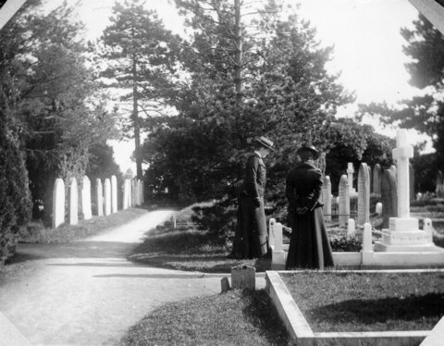
1. (1904 photo – courtesy Colin Reid)

FRIENDS PUBLISHING PLC - AGAIN!

I am delighted to announce that in addition to booklets on 'The Mayors of Worthing' and 'The Centenarians' our lovely bunch of researchers have now published a booklet on 'The Typhoid Epidemic' to be followed shortly by 'Businessmen and Shopkeepers of Worthing' Parts 1 and 2, all at £1 each and worth every penny! All Friends should have one of each, so place your order now or buy them when you attend our next cemetery tours and maintenance day, Saturday 1 October 2011 from 10.00. It is hoped that our Military book by Chris Green will be available by Remembrance Day.

ANOTHER GREAT OPEN DAY

The Friends of Broadwater and Worthing Cemetery can give themselves a large 'pat on the back' for the hugely successful Open Day held on Saturday 6 August 2011. It is estimated that at least 150 members of the public turned out and many enjoyed various cemetery tours, our many stands and photographs, great refreshments and a personal 'find a grave' service. The weather behaved itself until after proceedings had come to an end. We sold £63 worth of books, received £44 in donations, took £30 at the refreshment stall and took £12 in new membership fees. Although it would hardly dent the National debt the Treasurer was happy to add nearly £150 to our coffers. Above all else there was a wonderful atmosphere at the event and everybody went home happy and with a great sense of achievement.

To Sally Roberts the principal organiser and all of the Friends who participated, not only with a wide range of duties and responsibilities, almost too numerous to mention, but in supplying a variety of equipment, such as tables, chairs, gazebos, refreshments, laptop computers, maintenance tools of trade etc., our Chairman offered his personal appreciation of the massive 'corporate' effort. Well done everybody, you can proud of your input!

2.

SHEDDING THE LOAD

The Friends were confident of securing agreement in principle to the erection of a secure shed by the North Chapel of the cemetery however as we go to press a few planning issues have emerged, relating to the 'listed' status of the chapels. This useful facility will be used to store a range of maintenance and other tools, which the Friends hope to procure in the not too distant future. Various plans are being drawn up with the assistance of Paul Robards. Frank Ffitch and John Stepney are looking into the practical aspects of precise location, fixtures, fittings and no doubt security.

JEFFERIES BENCH IN MEMORIAL GARDEN
BY Michael Parrott

The Chairman of the Richard Jefferies Society, John Price, on entering the memorial garden dedicated to the natural history authors Richard Jefferies and W H Hudson, remarked that a seat should be placed in the space at the end of the path. It was decided to put it before the members at the AGM in October 2010, and was agreed that funds for a suitable park bench in an English hardwood should be made available. As I am tending Jefferies grave and a member of this group I was asked to purchase and install the seat. Local suppliers of garden furniture would not use English oak, as it rots too quickly when stood on wet ground; all right in a Tudor cottage for a few centuries I remarked. This led me to speak with a friend of mine, Terry Tyhurst, the blacksmith in the hundred year old forge at Glynde, a beautiful downland village a few miles east of Lewes. He had made many seats in the style of one Glynde green, which is dedicated to Queen Victoria on the occasion of her jubilee. This I felt was an ideal piece to honour both Jefferies and Hudson.

The two seater bench was delivered to the garden in the cemetery on the afternoon of 12 May 2011 by Terry and his lady assistant and bolted to the ground by him and John Stepney (thank you John). All present at the installation tested it for comfort and polished the brass plaque attached to it, which reads simply, 'Richard Jefferies Society 2011'. Thanks to them for the handsome addition to the memorial garden.

FACTS AND FIGURES

The Friends now have 70 fully paid up members and our Bank account has a credit balance of £13,922.54.
3.

ANNUAL GENERAL MEETING

Please note in your diaries NOW that the all-important Annual General Meeting will take place at 18.00 on Friday 28 October 2011 when all Friends will be able to exercise their democratic right to nominate, second or vote for postholders and nominees of all official posts within the Friends organisation. There will also be a full agenda where in addition to various important reports a number of policy issues will be discussed. Please make every effort to attend because it is also our THIRD ANNIVERSARY.

WITH A LITTLE HELP FROM MY FRIENDS
By Sue Nea
The Friends had planned to hold a themed tour on Saturday 2 July 2011, based on the stories of the victims of the terrible typhoid epidemic that hit Worthing in 1893.

Mary McKeown and already carried out a great deal of research on the victims who had died of typhoid during this time and who were buried in Broadwater and Worthing Cemetery. We decided, however, that we would also include some of the doctors who treated the victims and who were later, themselves buried in the cemetery. One of the doctors was Dr Augustus Collett who is buried in C9-47-23.

Jon Collett, a Friend of the cemetery who is involved in helping with our indexing of the monumental inscriptions, is the great grandson of Augustus. I contacted him and he kindly helped me with my research. I then visited Augustus' grave to look at the headstone prior to the tour and, although a large stone in fairly good condition, it was so dirty that you could hardly read the inscription. See photograph below:
4.
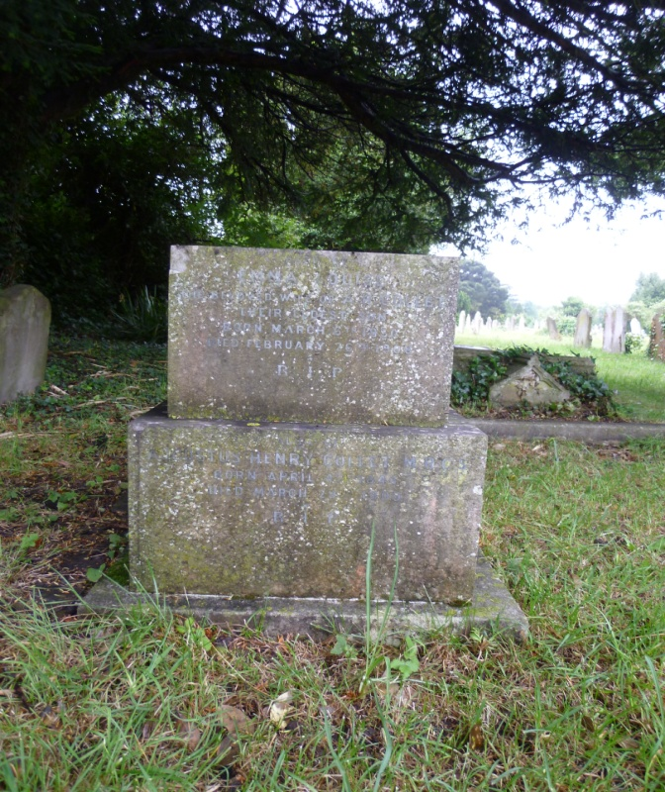

With Jon's permission, I contacted some of the Friends who have been trained in cleaning headstones and asked for a volunteer to clean the stone, which met with a great response. As it was Frank Ffitch undertook the work and he did a grand job. Suddenly it was so clean you could clearly read the inscription.

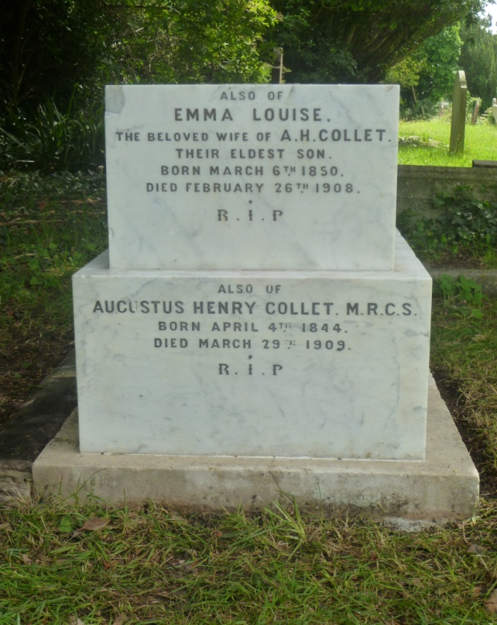
5.

Tour participants will now be able to view the grave and read the inscription themselves. Needless to say Jon was delighted with the results. On the day of the tour Jon asked me to introduce him to Frank because despite both being Friends they had never met! I found Frank clearing undergrowth and they duly met for the first time. This was a great story of Friends helping each other in several different disciplines – and everybody enjoyed the tour.

NATURE WATCH
By Paul Robards

The Spring of 2011 will be remembered as one of the driest on record leaving wildlife struggling to survive in such conditions.

The RSPB reported that Swallows and Martins returning from migration were finding it difficult to build their nests because of a shortage of mud. Garden birds also suffered with dry flower beds, being unable to break through the surface to find worms and Thrushes could find few slugs or snails, which favour damp conditions.

In the cemetery we are fortunate with a varied habitat of grass, shrubs, bushes and trees providing shelter and food for a wide variety of wildlife. The fortnight following 2 June when the grass was completely cut and strimmed the cemetery was completely abandoned by local birds and during my weekly walk it was sad to see all the flowers gone, while observing only two Speckled Wood butterflies near the Chapel.

If there are no flowers or grasses there is a knock-on effect to other species such as insects, butterflies and moths, which the birds depend on for their staple diet. In early July the Woodland Trust predicted a much earlier ripening of blackberries because of the dry Spring and that the amount of
fruit would be significantly reduced. They were right and the amount I collected was down on previous years, furthermore the remaining fruit was 'beyond its best' by the second week in August. Blackberries are a vital source of food for wildlife including not only birds but mammals, insects, wasps, butterflies and moths.

With the longer grass and the flowers being allowed to seed, the great number
of wild flowers, butterflies and grasshoppers was noticeable, resulting in favourable comments from cemetery visitors. The Pyramid Orchid was found
6.

at three separate locations in July and a grand display of Great Mullein in
Area C3 on the Edwin Snewin grave was noted, along with Bitter Sweet and thistles. The help of my Mother-in-Law, Kath, was invaluable in helping to identify some of the flowers in the cemetery, which included: Scarlet Pimpernel, Yellow Cordaylis, Birds Foot Trefoil, Nipplewort, Ribworth Plaintain, Prickly Lettuce, Linaria, Periwinkle, Lady's bedstraw, Strawberry Clover, Harebells, Red Dead Nettle, Vetch Glory in the Snow, Herb Robert, Valerian, Stonecrop (Sedum) and many, many others.

Some Friends will have seen my lovely Fox cub photographs [one of which is reproduced within-Ed.]. This was a wonderful 'one-to-one' experience. The young cub acted with curiosity and complete trust; I was possibly the first human he had come across. I am pleased to say that the fox and his family are still in the environs and there are many 'toys' about the cemetery, evidence of their playful nature.

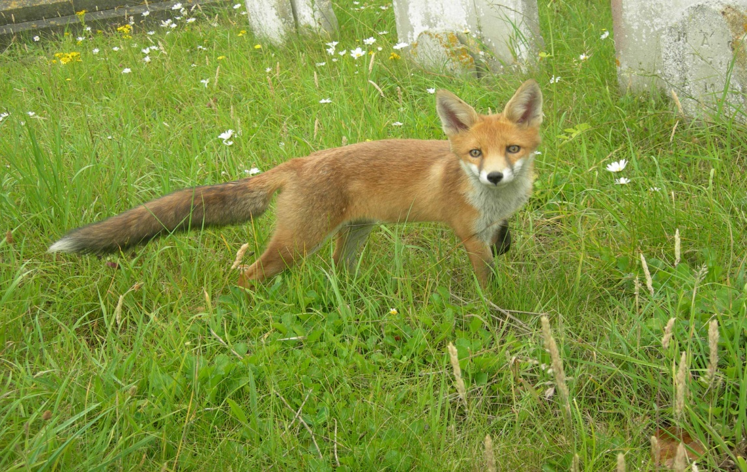

Sir David Attenborough stated recently that Britain's butterflies, including Britain's favourites the Tortoiseshells and Peacocks, are battling for survival and continue to be in long term decline, due to pesticides and destruction of their habitat. Environments such as Broadwater and Worthing Cemetery,
being in the middle of a built up area, vastly increases their chances of survival, so a big 'thank you' to the patience of those who would like to see the grass cut shorter. One observer has said that he would like to see the paths cut shorter and having had a word with Parks and Gardens at WBC this has
been agreed, along with some tarmac repairs, all in time for the
7.

Remembrance Parade in November this year. Finally while performing maintenance tasks in section A7 I thought my hand had been pricked by a Pyracanthas bush but on looking at my gardening gloves I realised that I had just been stung by a wasp. I told him that he had just stung the Wildlife Coordinator, to which the wasp replied he was only warning me that his nest (and his family) was in the corner of the grave being maintained and to make sure I only cleared around it.

Many thanks to all Friends who have passed on to me their welcome and appreciated observations.

ONE MAN WENT TO MOW
By Michael Parrott

I felt there was a certain reluctance at the July meeting to adopt the new mowing regime to give the cemetery a summer meadow appearance rather than a brown/green monoculture. True we need to get along paths to the various sections to read and record inscriptions. If managed correctly over the years the rank grass, which is the main cause of obstruction will be minimised and the wild flowers and grass seed heads will make a wonderful tapestry in the summer. The last cut should be in the autumn after the flowers have set seed and before the Remembrance Parade. The men commemorated in this beautiful spot surely would have dreamt of English wild flowers whilst fighting for our freedom in a foreign land? In in his essay 'Wild Flowers', published in one of his last books by Chatto & Windus in 1885 he wrote:

“If we had never before looked upon the earth, but suddenly came to it man or woman full grown, set down in the midst of a summer mead, would it not seem to us a radiant vision? The hues, the shapes, above all the sunlight, the breath of heaven, resting on it the mind would be filled with its glory, unable to grasp it, hardly believing that such things could be mere matter and no more...Unconscious happiness in finding wild flowers – unconscious and unquestioning, and therefore unbounded.”

[As mentioned in previous issues of THE BROADSHEET there is a delicate balance in maintaining the cemetery to a reasonable standard and to the best
of our ability but falling short of it becoming (only) a nature reserve, where hours of toil are negated by not disturbing a few weeds that are bound to be a habitat for something. Certainly the timing of the Council's mega trim needs to be looked at because wild flowers do add colour. Somewhere within this complex web of varying interests is a solution, even if it is not perfect in the eyes of all concerned– see our Coordinator's 'Nature Watch' above – Ed.]
8.
RECORDS OFFICE CONSULTATIONS
By Sue Nea

In the height of Summer Debra Hillman, Mary McKeown and myself attended a meeting with the Caroline Adams of the West Sussex Records Office at Chichester. Also in attendance were Marion Woolgar and Barrie Keech who represented the West Sussex Archive Society. The purpose of the meeting was to try and gain access to the records of the Worthing Registrar of Births, Marriages and Deaths (who is located at the WSRO) for the purposes of genuine bona fide research by responsible public interest organisations [such as the FBWC and the WSAS], thereby avoiding the draconian charges of £9.25 per certificate through usual channels. Such access would be invaluable when researching, by way of example, the victims of the Typhoid Epidemic because obtaining the certificates is the only certain way to determine whether somebody actually died of typhoid. The results of this joint approach are awaited.

FRIENDS HELP THE PUBLIC AGAIN!

During recent months there have been many occasions when accolades have been received by the Friends from members of the public following assistance provided in locating graves, cleaning headstones and assisting in other ways. A lady called Sheila Gammon asked how she could get the grave of her Grandmother (Ellen Oswald) cleaned. She had only just traced where she was buried. John and Pam Stepney in their usual helpful way set about cleaning the memorial and Sheila Gammon came along to see it on one of our tour days to see the result. She was so delighted that she called the transformation 'a miracle'! She immediately joined the Friends and in addition made a donation of £50. We reciprocated in giving her one of our 'A-Z' books.

In another instance there was an e-mail from 'Downunder' following the publication of a BROADSHEET article on the Rev. William Kew Fletcher penned by John Stepney. Mark William Fletcher wrote from Sydney, Australia saying that “After one of my fellow mad keen family researchers passed on a copy of your 'THE BROADSHEET', Issue No.10, I just had to drop you a line and thank so much John and Pam Stepney for their article concerning the grave of my Great Great Grandfather the Rev William Kew Fletcher. My research had taken me as far as determining he had been buried in Broadwater and Worthing Cemetery but I never dreamed someone would take interest enough to do a little 'digging' for themselves”. Mark gave many interesting additional facts about his family's ancestors before ending “Thanks so much once again for your publication and all your preservation efforts”.

As Debra Hillman pointed out “Yet another relative reached thanks to the World Wide Web and our newsletter”.
9.
CEMETERY HUMOUR

The hairdressing shop next to the cemetery at Rupert, Idaho is called
“Curl Up and Dye”!
---------------------------------------
Inscription on a memorial at Belen , New Mexico
“Here Lies Mary Smith - Silent At Last”!
----------------------------------------
It wasn't the cough that carried him off –
it was the coffin they carried him off in.
----------------------------------------
From the Sunday Times 26 June 2011 (via Rosemary Pearson)

The body of Ken Manis, 76, is to be exhumed after he was buried with another patient's dentures in a mix-up at Chattanooga, in the USA.

RESEARCHER'S CORNER
HENRY JOHN KINNIARD C19/1/23-25
By Pam Stepney

In THE BROADSHEET Issue No.6 Mary McKeown wrote an article about artist Edwin Douglas who was buried in Section C17. I wondered if Friends were aware that there is another artist buried nearby in Section C19.

Henry John Kinniard was born in London in 1861. His Father had been an artist and Henry soon followed in his footsteps. He became a prolific painter of landscapes and at the age of 19 began exhibiting his work at the Royal Academy and the Royal Society of British Artists. At that time he was living in the then fashionable area of
Camden Town. He painted mainly river scenes on the Thames and his studies of rural life brought him great popularity.

In 1883 he married Alice Mary Leyland a farmer's daughter and they had a son and
a daughter before Alice died in 1890. In 1892 Henry married again to Mary Helen

Cooke, Principal of Chingford Young Ladies School and he fathered another son and daughter. In 1901 the family moved to Homefield Road, in Worthing and the surrounding Sussex countryside inspired a great many more of Henry's paintings. Examples of his work include 'Haymaking in a Sussex Landscape', 'A Sussex Cornfield', 'View near Ashington, Sussex', 'Near Bramber, Sussex', 'A Sussex Farm' and many others. By now Henry was becoming very well known for his fine work.
10.

By 1911 Henry and his family had moved to 'Elm Croft', Burpham, near Arundel. This was a wonderful location for a landscape artist and having the River Arun and Arundel Castle on his doorstep inspired still more beautiful paintings, such as 'The Old Bridge on the Arun, Sussex' and 'Cornfield near Arundel'. Later in life Henry moved to Ringmer, near Lewes where he died in 1929. Many examples of his work can be seen on the internet and his paintings still sell well both in the UK and the USA. In December 2003 'A Sussex Lane' sold for $2,643 and in May 2007 'Near Arundel, Sussex' sold for £1080.

Henry Kinniard is buried with his wife and his son and daughter by his first marriage, and his second daughter Margaret, who died aged 17 in 1915. She was remembered by her school friends of Broad Oak, Reading, Berkshire on a plaque.

AUGUSTUS ROBERT SCHUTZ A10-2-53
By Anne Powell

Augustus Robert Schutz was born about 1845 in Germany, the descendant of a long line of well-to-do farmers. He was given a good education as well as instruction in farming, which his parents wanted him to continue. However farming was hard at that time and as Augustus was a talented musician he was encouraged to go to England to make his fortune in that profession. He began his musical career at Brighton and later in Weston-super-Mare and Bath, before settling in Worthing.

The 1871 census shows him lodging in Broadwater with three other German musicians and another living next door. All from the same part of Germany.

He was a founder member of the Rhine Band that once played on the pier and on the seafront at Worthing in the late Victorian times. There were Rhine Bands in other English towns; it seems young German musicians migrated to England to try and make their fortunes.

In 1879 he married a widow, Mary Maria Earl, nee Haydon, and they set up home at 21 Ann Street, Worthing. Their first child, Albert Augustus, was born later that year, quickly followed by Margaretta Jenny in 1880, Frederick Charles in 1882, William Hayden in 1883(who died in 1884) and their last child Henry Albury in 1885. Unfortunately Mary died in December 1887 [hardly surprising! Ed.] leaving Augustus to bring up their four children with the help of stepdaughter, Annie.

The profession of musician was precarious and in the 1881 census he was described as a 'commercial agent' but in a later census a 'teacher of music'. Music was not his only love and he became a self-taught astronomer. He was made a member of the British Astronomical Association and in 1892 he published a work entitled 'The Celestial Symphony'. The following year he made his début at the Assembly Rooms as a lecturer of Astronomy and contributed articles to the Gazette on astronomical subjects. He was always to be found on the seafront with his powerful telescope, which he would let the public use for a small fee while sharing his knowledge with them.

After a long and painful illness Augustus died, aged 66, at his home, which was then 41 Grafton Road, Worthing and is buried in Broadwater and Worthing Cemetery.

CHARLES C COOK C7-01-33
By Paul Robards

I recently won on E-Bay an item of written ephemera in the form of a memo from Charles C Cook, a brick maker of High Street, Worthing, dated 22 May 1902 addressed to Messrs Sparks & Son of Arundel. It reads;

Dear Sir,

I shall be obliged by your sending, as soon as possible to Goring station as before, 1 truck of moulding sand.

Yours faithfully

Charles C Cook

The memo was posted to Arundel by a half penny stamped card and duly franked '7.15pm – 22 May 1902'.

I researched the name Charles C Cook, firstly on the Worthing Borough Council web-site and secondly in the burial records and found Charles buried at Broadwater and Worthing Cemetery in Plot C7-01-33. The records state that Charles Christopher Cook a retired brick maker of Purbrook, North Street, Worthing died in June 1914, aged 72 years.
12.

Having found this I went to the cemetery and found the plot in area C7 along with other members of the Cook family. In Plot 30 was Julia Cook, aged 69 years, in Plot 31 Phyllis Cook, along with Sir Frederick and Brigadier Ernest and wife Fanny Cook in Plot 32. Also buried was Constance, youngest daughter of the late Charles and Fanny Cook and Gertrude Fanny, eldest daughter.

I returned home and looked up on the internet Sir Frederick Cook and found the following on an 'Architect & Builders' website:

COOK, Frederick Charles (1875-1947) Urban District Council 1900-1903.

“On a visit to Hinkley by the Leicestershire Surveyors Association in 1930, the Leicester City Engineer, A C Gooseman, stated that “Major F C Cook, a former surveyor of Hinkley, now looked upon as one of the leading engineers in the country. (Hinkley Times 26 September 1930). Born in 1875, the son of C C Cook of Worthing, he married Amelia May, daughter of G F Bult, with whom he had three sons. He was articled to Miles Aspinall, civil engineer, and subsequently held various civil engineering posts in local government (including that of Surveyor of Hinckley UDC) [He served in the Royal Engineers during the 1914-1918 war, was mentioned in despatches and was awarded the Military Cross, the Distinguished Service Order and Croix de Guerre]. He became Engineering Inspector of the Ministry of Transport in 1920, Divisional Road Engineer in 1921, Deputy Chief Engineer in 1929 and Chief Engineer in 1935. He retired in 1942 but remained with the Ministry of Transport for three years in an advisory capacity and acted as Chairman of many important government committees.

He was created a CB in 1937 and Knighted in 1942. He was a Member of Council, Institute of Civil Engineers, FSI and Honorary Member of the Institute of Royal Engineers and of the Institute of Municipal and County Engineers. He was a partner in Howard Humphrey & Sons, Consulting Engineers, Westminster. His home was The Mount, Ashtead Park, Ashtead, Middlesex, where he died (some information from Who's Who 1946 and Who Was Who 1941 to 1950).
13.
Frederick died on 19 May 1947 and he is buried at Broadwater and Worthing Cemetery Plot C17-01-31. 'So not just a leading engineer in the country, a leading man'

To add some local history content, in about 1773 a local man called Thomas Wicks was making red bricks in Worthing. He later discovered on Worthing common a blue clay exposed by sea erosion, which made white or cream bricks. Those were used to front many buildings in Worthing and elsewhere; their production still being recorded in the early 1830s. In 1870 the Worthing Land Improvement Company made bricks, and other local brick makers were recorded in the 19th century. There were three brick yards at the west end of the town in 1848 and four firms of brick and tile makers in Worthing and one in Durrington in 1905. Local bricks were in use until about 1910.

EDITOR'S RAMBLINGS

A personal 'thank you' to Sally Roberts for cleaning and restoring the headstone of my maternal Great Grandfather's grave, William Austin Morley at B15-12-4, who died in 1918. The large stone looks 'just like new'.

I am pleased to report YET ANOTHER wonderful turnout on Saturday 3 September 2011 when three tours were very well populated by a total of 61 people, as the Friends sold books, found graves, maintained the same, conducted tours, noted inscriptions etc. It is a pleasant surprise that interest in our efforts is, apparently, being sustained.

Worthing's Heritage long weekend of events will see the Friends conduct another half dozen tours throughout the day on 10 September offering a special thematic insight into our better known past citizens, weather permitting!

It has been a tremendous Summer season that greatly exceeded our expectations but there will be plenty to be getting on with this Autumn as we go from strength to strength. See you at the next meeting on Friday 30 September, at the cemetery on 1 October or at the AGM on 28 October – note those diaries!

John Vaughan
EDITOR

14.

